**A**

### **Project Report**

### **On**

### **Musical Instrument Tuner and Practice Assistant**

**Submitted by**

### **Mr. Naresh Anil Sondkar**

**Roll No.: 22161**

**MCA–I**

**SEM–I**

**Under the guidance of**

### **Prof. Amruta Deshmukh**

**For the Academic Year 2022-23**



***Sinhgad Technical Education Society’s***

**Sinhgad Institute of Management**

**Vadgaon Bk Pune 411041**

**(Affiliated to SPPU Pune & Approved by AICTE New Delhi)**

### 

### Date:

**CERTIFICATE**

This is to certify that Mr. Naresh Anil Sondkar has successfully completed his project work entitled **“Musical Instrument Tuner and Practice Assistant”** in partial fulfillment of MCA – I SEM –I Mini Project for the year 2022-2023. He has worked under our guidance and direction.

### Prof. Amruta Deshmukh Dr. Chandrani Singh

**Project Guide Director, SIOM-MCA**

### Examiner 1 Examiner 2

**Date:**

**Place:** Pune

**DECLARATION**

I certify that the work contained in this report is original and has been done by me under the guidance of my supervisor(s).

* The work has not been submitted to any other Institute for any degree or diploma.
* I have followed the guidelines provided by the Institute in preparing the report.
* I have conformed to the norms and guidelines given in the Ethical Code of Conduct of the Institute.
* Whenever I have used materials (data, theoretical analysis, figures, and text) from other sources, I have given due credit to them by citing them in the text of the report and giving their details in the references.

### **Name and Signature of Project Team Members**:

|  |  |  |  |
| --- | --- | --- | --- |
| **Sr. No.** | **Seat No.** | **Name of students** | **Signature of students** |
| **1** | 22161 | **Naresh Anil Sondkar** |  |

**ACKNOWLEDGEMENT**

It is very difficult task to acknowledge all those who have been of tremendous help in this project. I would like to thank my respected guide **Prof. Amruta Deshmukh** for providing me necessary facilities to complete my project and also for their guidance and encouragement in completing my project successfully without which it wouldn’t be possible. I wish to convey my special thanks and immeasurable feelings of gratitude towards **Dr. Chandrani Singh, Director SIOM-MCA.** I wish to convey my special thanks to all teaching and non-teaching staff members of **Sinhgad Institute of Management, Pune** for their support.

Thank You

Yours Sincerely,

Naresh Anil Sondkar

# INDEX

|  |  |  |
| --- | --- | --- |
| **Sr. No.** | **Chapter** | **Page No.** |
| 1 | **CHAPTER 1: INTRODUCTION** |  |
| 1.1 | Abstract | 6 |
| 1.2 | Existing System and Need for System | 7 |
| 1.3 | Scope of System | 8 |
| 1.4 | Operating Environment Hardware and Software | 9 |
| 1.5 | Brief Description of Technology used | 10 |
| 2 | **CHAPTER 2: PROPOSED SYSTEM** |  |
| 2.1 | Feasibility Study | 11 |
| 2.2 | Objectives of the proposed system | 12 |
| 2.3 | Users of the system | 13 |
| 3 | **CHAPTER 3: ANALYSIS AND DESIGN** |  |
| 3.1 | Entity Relationship Diagram (ERD) | 14 |
| 3.2 | Class Diagram | 15 |
| 3.3 | Use Case Diagrams | 16 |
| 3.4 | Activity Diagram | 17-20 |
| 3.5 | Sequence Diagram | 21-23 |
| 3.6 | Component Diagram | 24 |
| 3.7 | Module and Hierarchy Diagram | 25 |
| 3.8 | Table Design | 26-29 |
| 3.9 | Data Dictionary | 30 |
| 3.10 | Sample Input and Output Screens  (Screens must have valid data. All reports must have at-least 5 valid records.) | 31-33 |
| 4 | **CHAPTER 4: CODING Sample code** | 34-39 |
| 5 | **CHAPTER 5: LIMITATIONS OF SYSTEM** | 40 |
| 6 | **CHAPTER 6: PROPOSED ENHANCEMENTS** | 41 |
| 7 | **CHAPTER 7: CONCLUSION** | 42 |
| 8 | **CHAPTER 8: BIBLIOGRAPHY** | 43 |

1. **CHAPTER 1: INTRODUCTION** 
   1. **Abstract**

The affinity towards the music in peoples is increasing. Many of the peoples likes to play the music instruments. Talking about music instrument almost every non-electric musical instrument it is mandatory that it is tuned in its respective scale if we want it to make nice sound from it. For this purpose tuner is needed. Practice is a main aspect in the life of a musician. Practicing alone is another problem so our website will be the solution for all these problems faced by the musician.

**1.2 Existing System and Need for System**

* Professional musicians tunes their music instruments manually because they have that much experience in the field.
* There are many expensive electronic gadgets are available in market for tunning the instrument.
* For a beginner it is very difficult to tune the instrument manually because they don’t have that much experience.
* Also our website will provide accuracy.
* Our website will help them to tune their instrument in easier and automatic way. For practicing purpose there is no any particular system is available as practice is main aspect in the learning process of any musical instrument, our website will help the user to increase their knowledge and experience.

**1.3 Scope of System**

**•** The Musical instrument tuner is useful for beginners.

• It can be used anywhere any time as it is a Web based application.

• It is free to use, cost efficient as it is freely available on the web.

• This system will provide better and easy access to different features.

• As soon as a user visits the websites he can access different tutorials of various musical instruments .

• The administrator keeps on updating the information from time to time.

**1.4 Operating Environment Hardware and Software**

**Hardware :**

1. CPU : Pentium IV or above.
2. RAM : 2GB or greater
3. Hard Disk Space : 50GB

**Software:**

1. Backend : JSP & servlet
2. Frontend : HTML and CSS, javascript
3. Database : Mysql
4. Server : Tomcat
5. Operating system : Windwos 10

**1.5 Brief Description of Technology used**

* We used html, css & javascript as the front end of our project because they have many designing options.
* CSS provides us with many options to make our user interface we used flex layout to manage the layout of pages.
* Javascript is used to handle client-side events also audio drivers in js are used to get input and provide it to the backend.
* Using jsp and servlet for server-side programming we are able to write java

**CHAPTER 2: PROPOSED SYSTEM**

**2.1 Feasibility study**

* **Operational Feasibility:**

The website has been developed by making the consideration of novice users. there is absolutely no need for any software professional to handle the system. The simplicity and user friendliness of the system will allow even a non IT background person to handle with some prior instructions and understanding of the system is viable from all aspects.

* **Technical Feasibility:**
  + The manual tuning of the instrument is not that much accurate so our functionality will provide up to 99% accuracy in tuning.
  + Talking about practice without any technical support is not that much easy to evolve.
  + Our user can get technical support while practicing alone.
* **Economical Feasibility:**

In todays world everyone have at least a simple android phone which is no that expensive as compare to the electronic gadgets available related to the music instrument learning process.

So our website is economically feasible for every user

**2.2 Objectives of the proposed system**

* Introduce a user-friendly platform for new music students who started their journey to become a musician.
* To help the user to tune its musical instrument very accurately.
* Make users’ music practice more interesting and comfortable according to their choice.
* To give the user a platform to record their music and examine it.
* Increasing theoretical knowledge related to music with the help of small quiz.

**2.3 Users of System**

1. Music Instrument Learners
2. Professional Musicians
3. Music Teachers
4. Sound Engineers
5. Recording Studio Assistants

**CHAPTER 3: ANALYSIS AND DESIGN**

**3.1 Entity Relationship Diagram (ERD)**

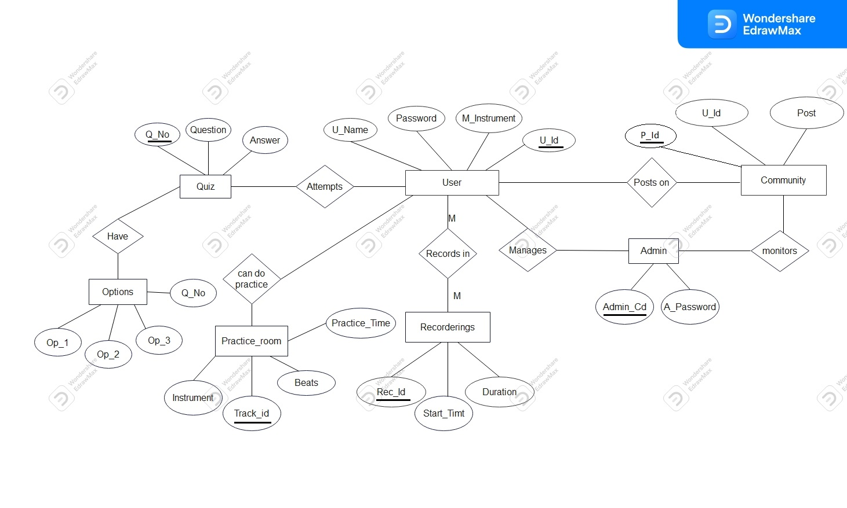

**3.2 Class Diagram**

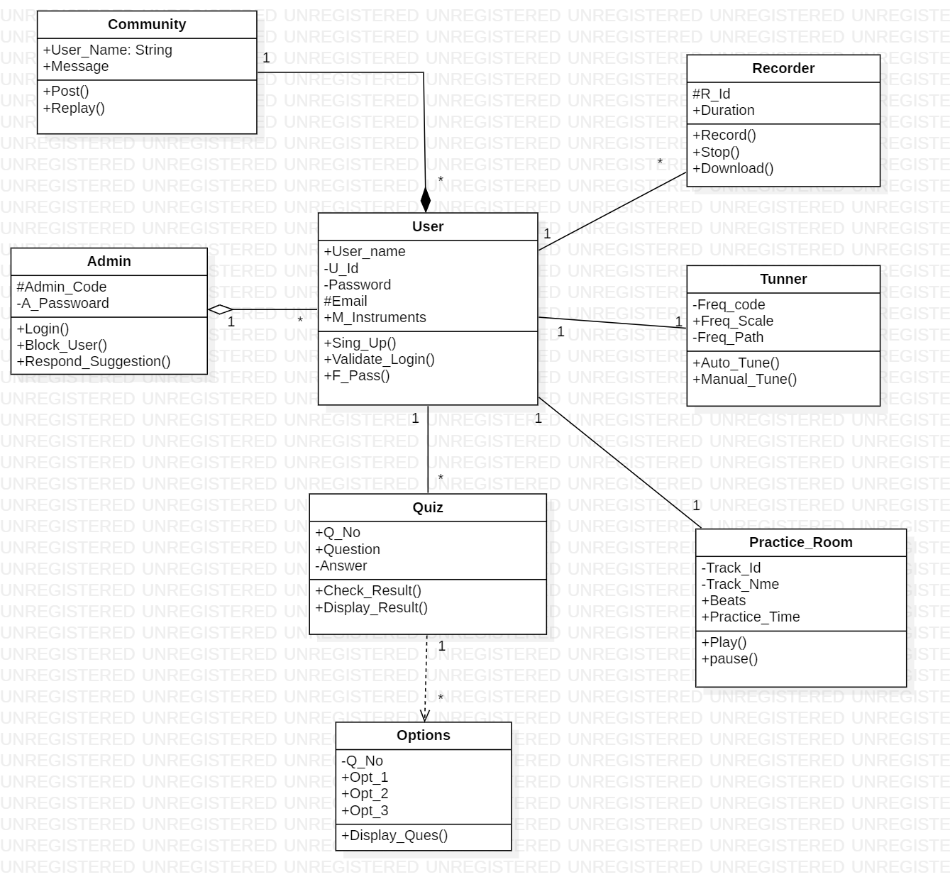

**3.3 Usecase Diagram**

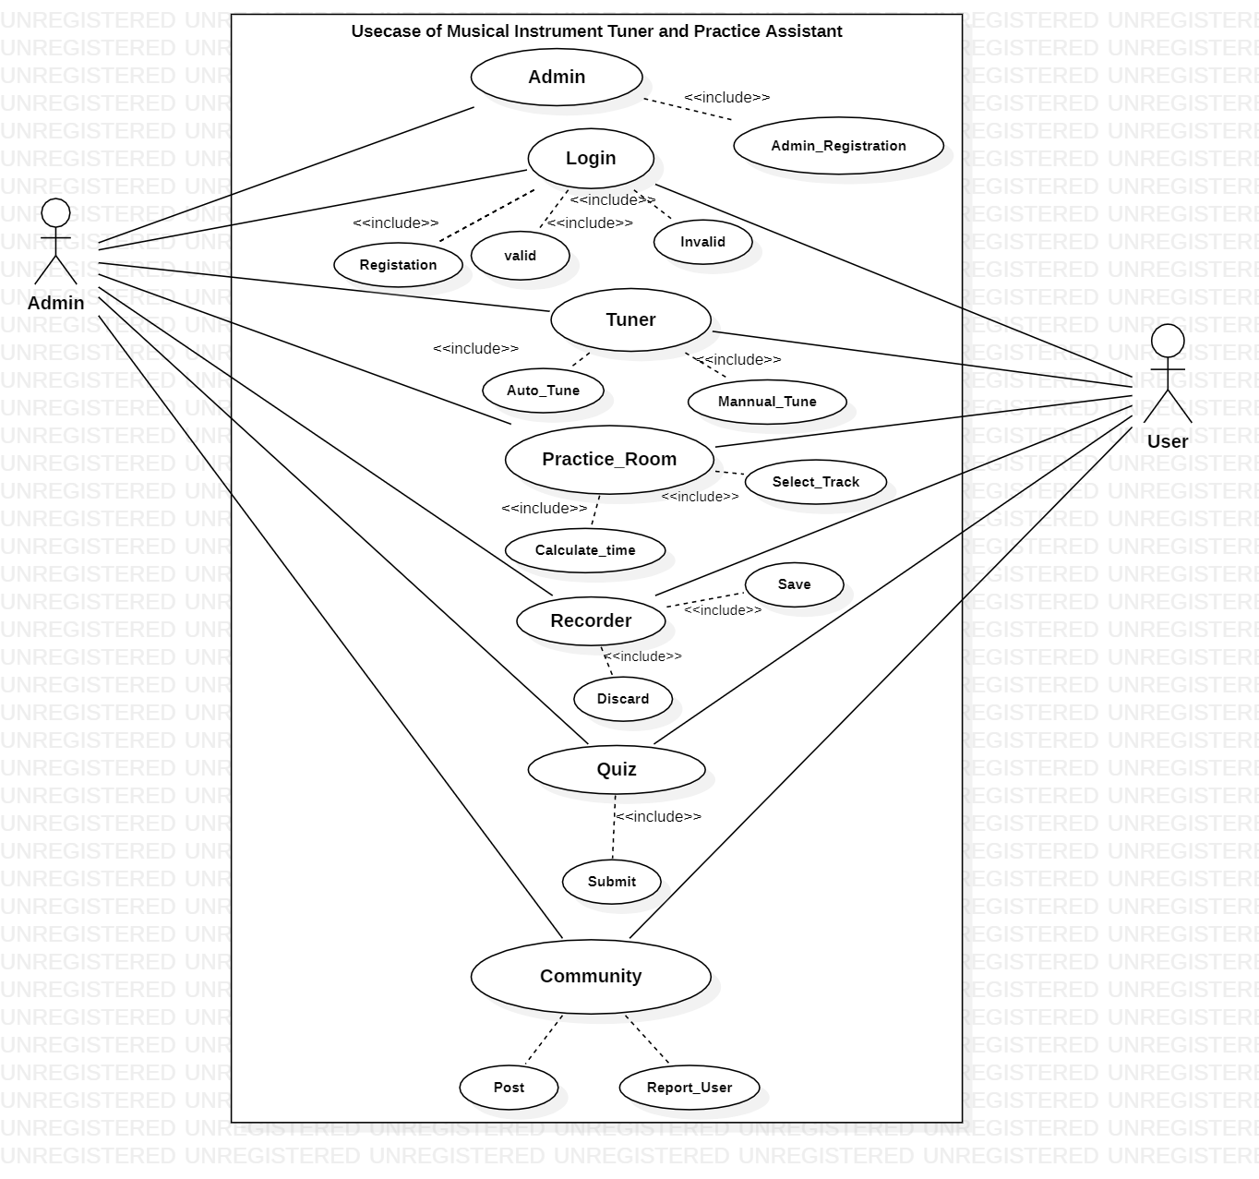

**3.4 Activity Diagram**

* **Tuner Module Activity Diagram**

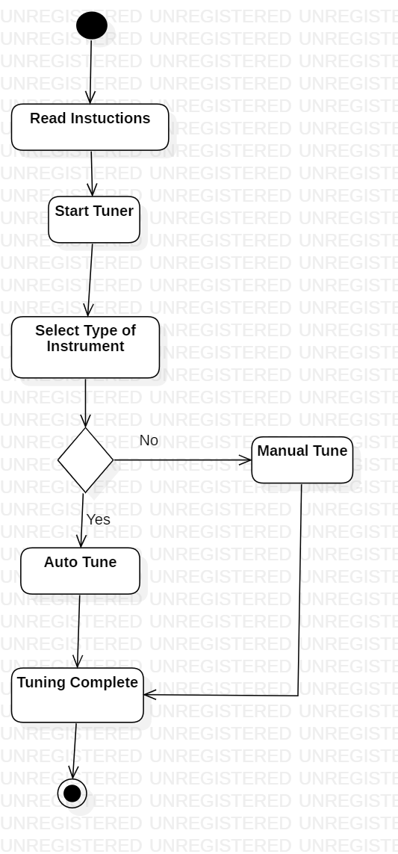

* **Recorder Module Activity Diagram**

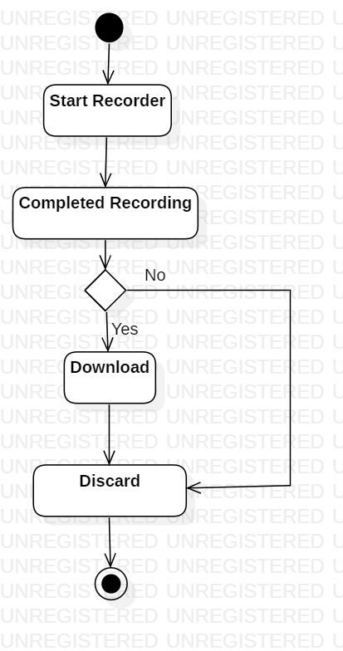

* **Practice Module Activity Diagram**

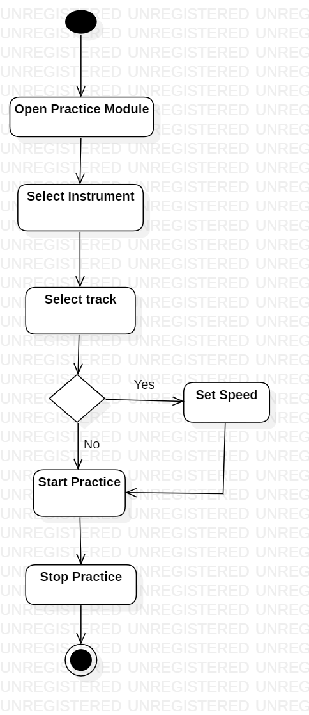

* **Quiz Module Activity Diagram**

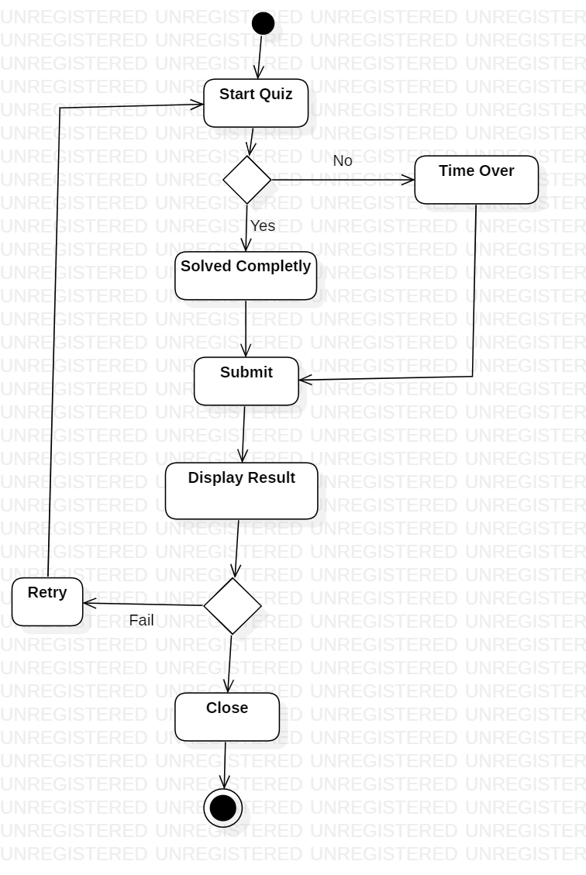

**3.5 Sequence Diagram**

* **Tuner Module Activity Diagram**

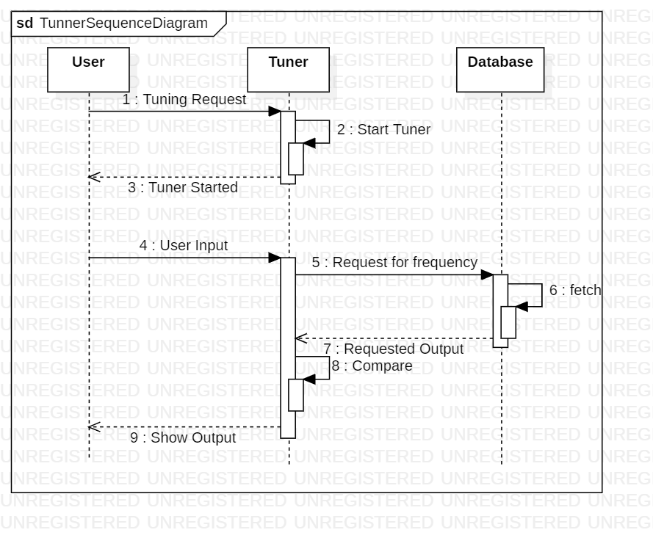

* **Practice Module Sequence Diagram**

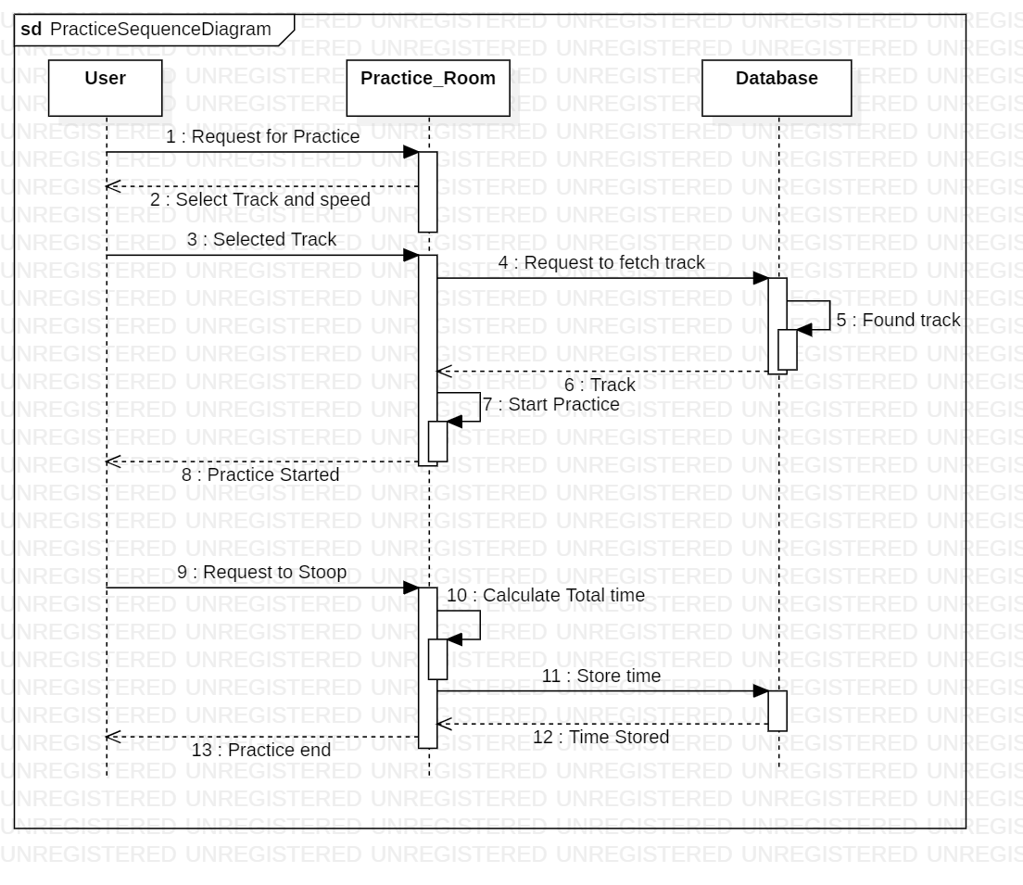

* **Quiz Module Sequence Diagram**

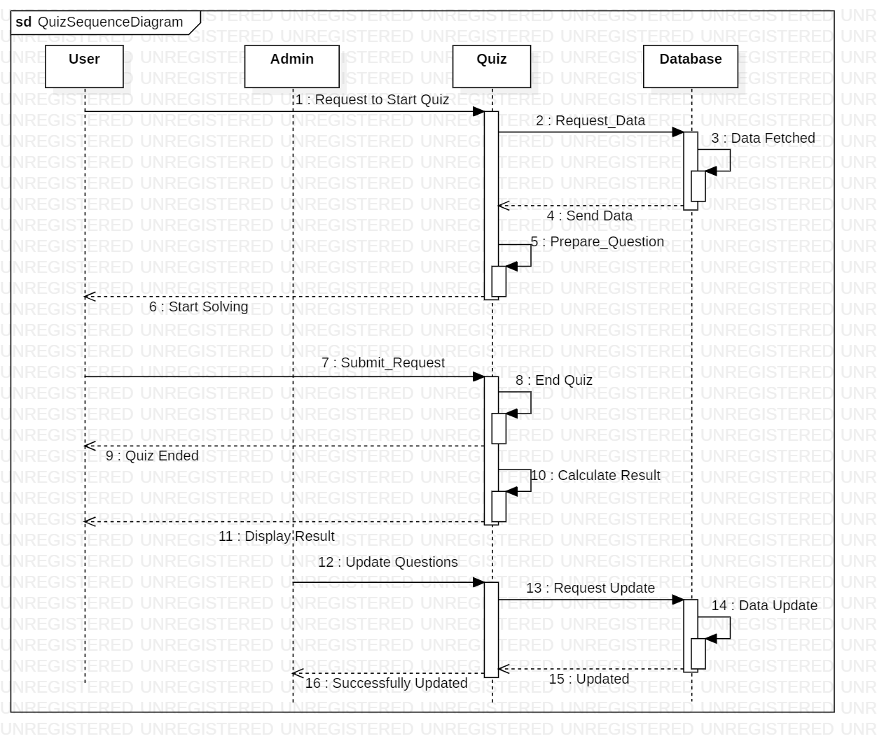

**3.6 Component Diagram**

Authentication from user Database

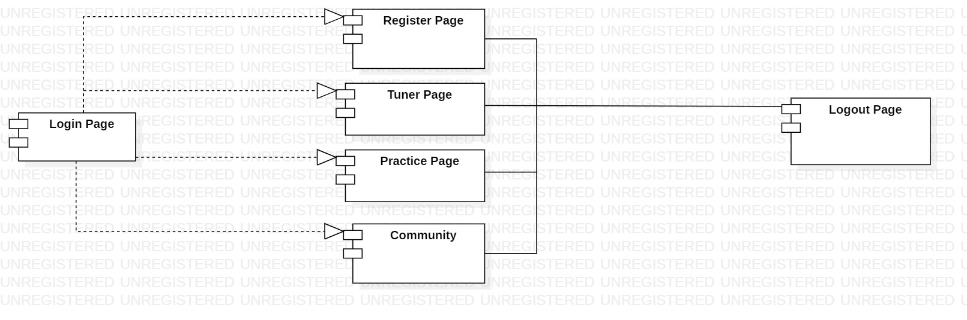

**3.7 Module Hierarchy Diagram**

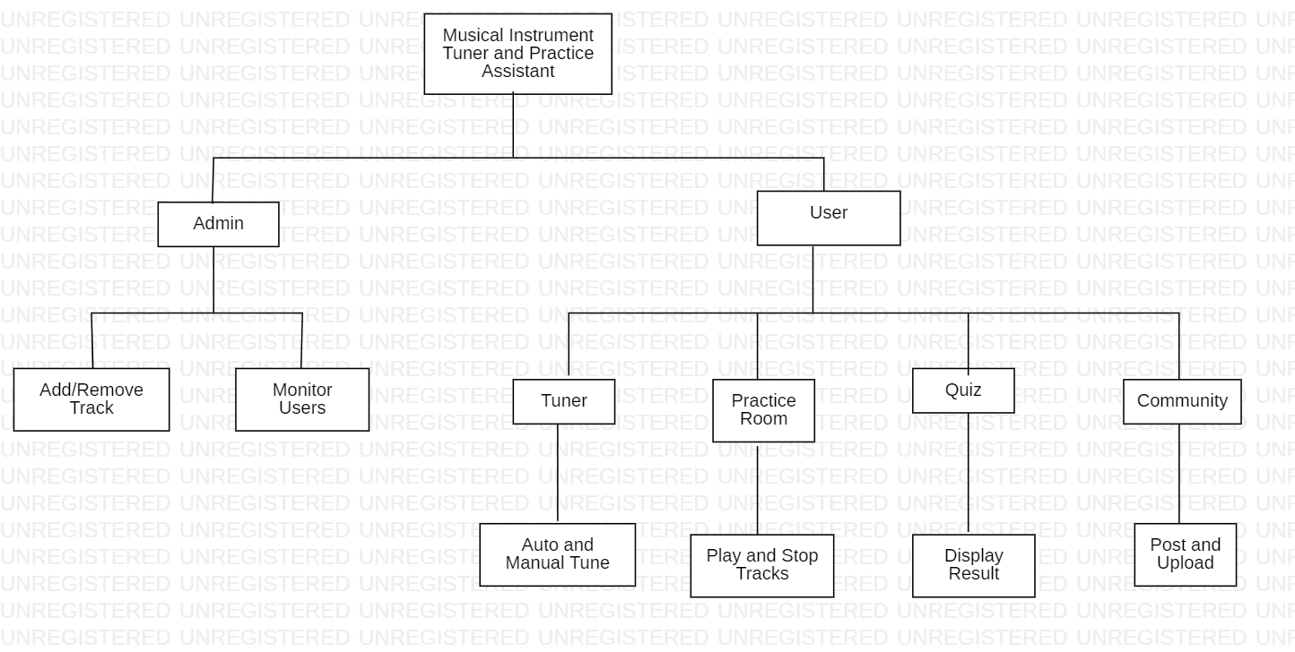

**3.8 Data specification**

* **User Table**

|  |  |  |
| --- | --- | --- |
| **Field** | **Data Type** | **Description** |
| U_Id | int | Id of the user |
| Username | varchar | Username of the User |
| Musicinstrument | varchar | Musical Instruments |
| Password | varchar | Password of the User |
| Email | varchar | Email of the User |

* **Quiz Table**

|  |  |  |
| --- | --- | --- |
| **Field** | **Data Type** | **Description** |
| Quiz_No | int | No of the Quiz |
| Instrument | varchar | Type of the instrument |
| Q_No | varchar | No of questions in the quiz |
| Answer | varchar | Answers of the quiz |

* **Track Table**

|  |  |  |
| --- | --- | --- |
| **Field** | **Data Type** | **Description** |
| T_Id | int | Id of the track |
| T_Name | varchar | Name of the track |
| T_Duration | time | Duration of the track |
| T_Location | varchar | Location in database |

* **Tuner Table**

|  |  |  |
| --- | --- | --- |
| **Field** | **Data Type** | **Description** |
| S_id | int | Id of the scale |
| S_Name | varchar | Name of the scale |
| S_Range | varchar | Frequency range |
| S_Location | varchar | Location in database |

* Recordings Table

|  |  |  |
| --- | --- | --- |
| **Field** | **Data Type** | **Description** |
| R_id | int | Id of the recording |
| R_name | varchar | Name of the recording |
| R_duration | time | Duration of the recording |
| R_Location | varchar | Location in database |

**3.9 Data Dictionary**

|  |  |  |  |  |
| --- | --- | --- | --- | --- |
| **Field** | **Data Type** | **Size** | **Constraints** | **Table** |
| Answer | varchar | 20 | Not null | Quitb |
| Email | varchar | 100 | Unique Not null | Usertb |
| MusicInstrument | varchar | 20 | Not null | Usertb |
| MusicInstrument | varchar | 20 | Not null | Quitb |
| Password | varchar | 15 | Not null | Usertb |
| Q_No | varchar | 10 | Not null | Quitb |
| Quiz_No | int | 10 | Primary Key | Quitb |
| R_duration | time |  | Not null | Recordingstb |
| R_id | int | 5 | Primary Key | Recordingstb |
| R_Location | varchar | 75 | Not null | Recordingstb |
| R_name | varchar | 50 | Not null | Recordingstb |
| S_id | int | 20 | Primary Key | Tunertb |
| S_Location | varchar | 75 | Not null | Tunertb |
| S_Name | varchar | 3 | Not null | Tunertb |
| S_Range | varchar | 15 | Not null | Tunertb |
| T_Duration | time |  | Not null | Tracktb |
| T_Id | int | 5 | Primary Key | Tracktb |
| T_Location | varchar | 3 | Not null | Tracktb |
| T_Name | varchar | 75 | Not null | Tracktb |
| U_Id | int | 10 | Primary Key | Usertb |
| Username | varchar | 75 | Not null | Usertb |

3.10 Sample Input and Output Screens

* Home Page

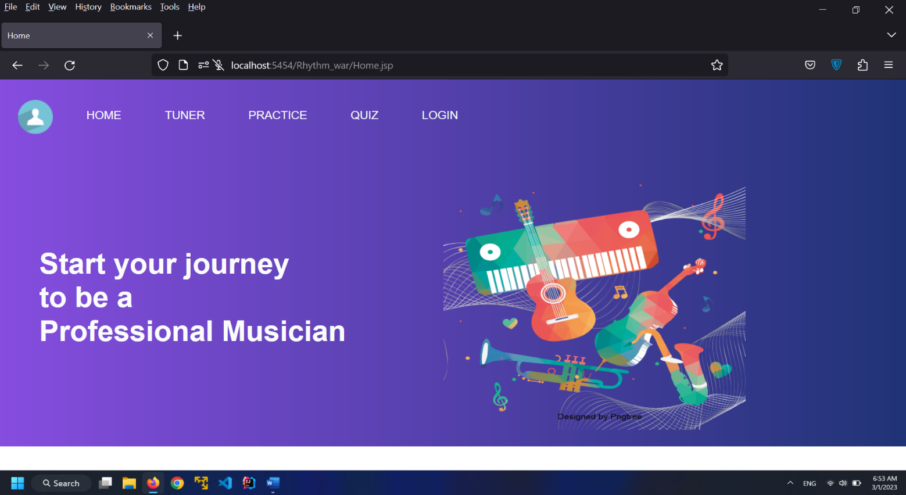

* Registration Page

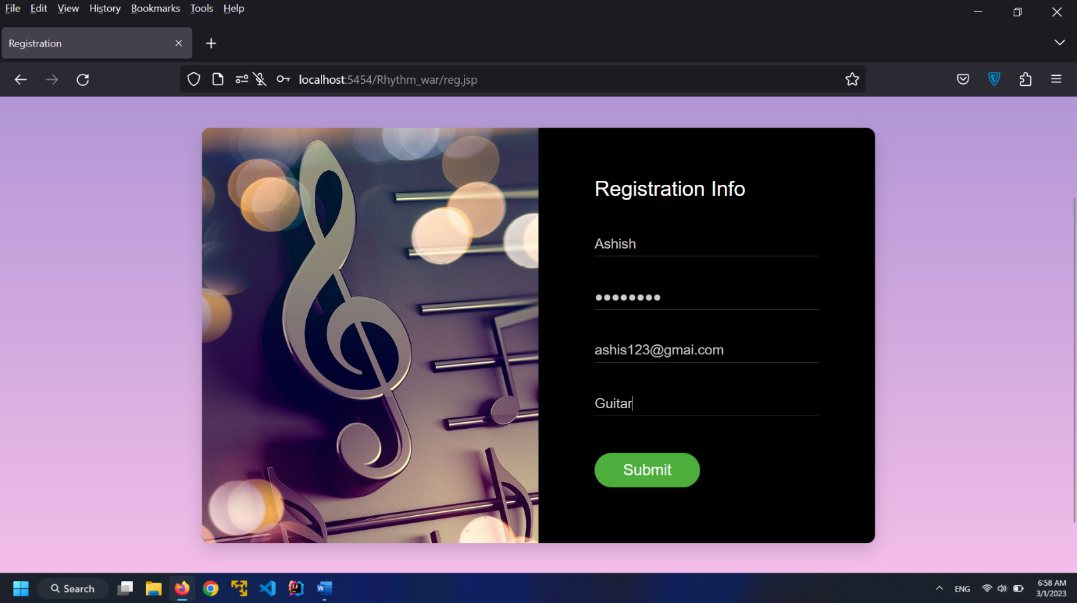

* Login Page

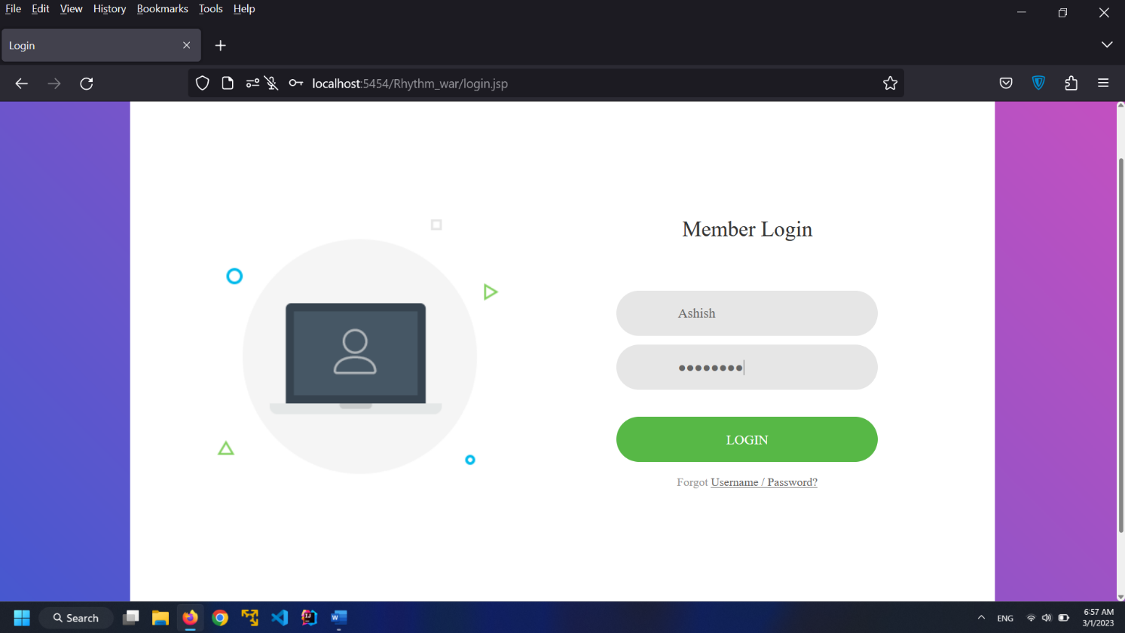

* Music Instrument tuner

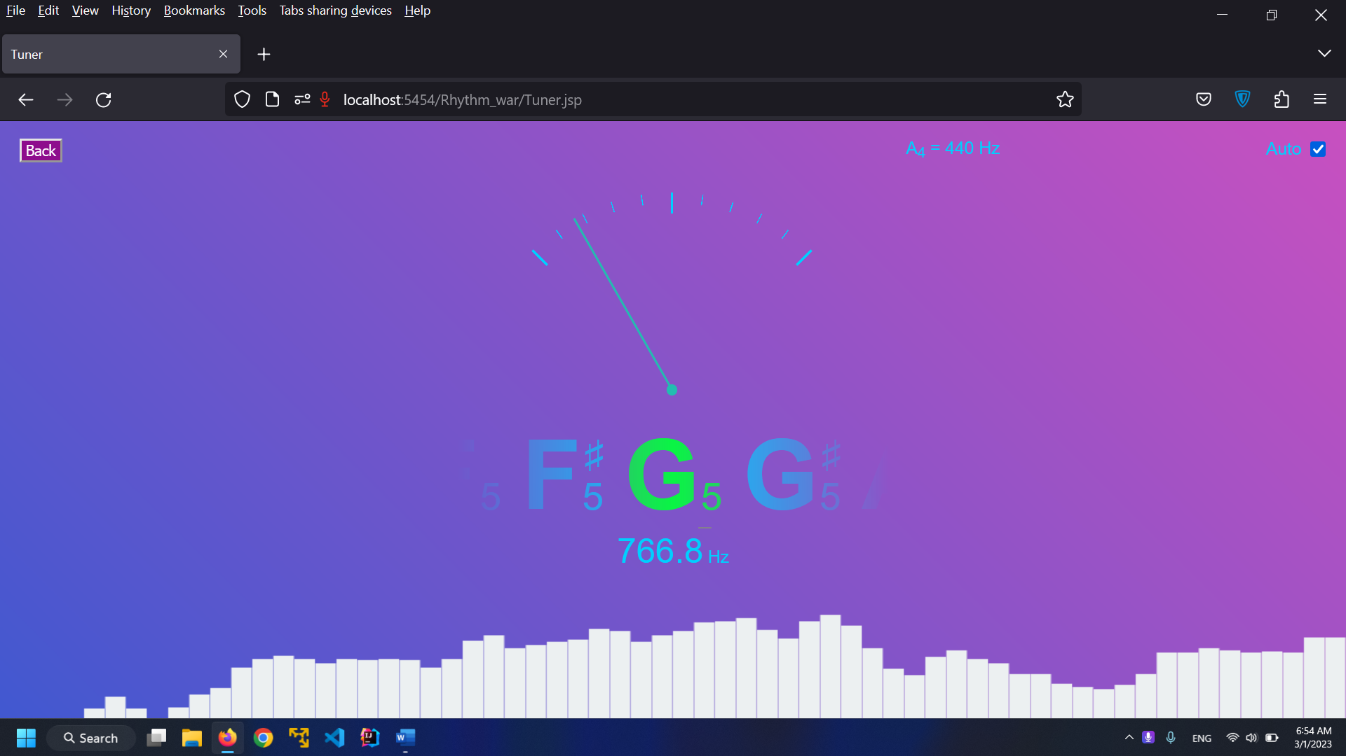

* Practice Page

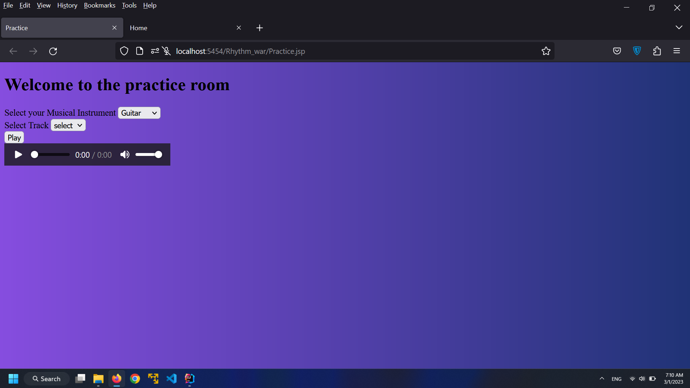

**CHAPTER 4: CODING Sample code**

* **Practice.jsp**

**<%--**

**Created by IntelliJ IDEA.**

**User: FX566LI**

**Date: 2/24/2023**

**Time: 10:39 AM**

**To change this template use File | Settings | File Templates.**

**--%>**

**<%@ page contentType="text/html;charset=UTF-8" language="java" %>**

**<%@page import="myRhythm.Classes.Practice"%>**

**<html>**

**<head>**

**<title>Practice</title>**

**<link rel="stylesheet" href="css/practice.css" />**

**<link rel="stylesheet" href="css/style.css" />**

**<link href="https://cdnjs.cloudflare.com/ajax/libs/font-awesome/4.7.0/css/font-awesome.min.css" rel="stylesheet" />**

**<link href="https://use.fontawesome.com/releases/v5.6.3/css/all.css" rel="stylesheet" />**

**</head>**

**<body>**

**<div class="bck">**

**<button type="submit" onclick="window.location.href='Home.jsp'" id="bckbtn">Back</button>**

**</div>**

**<div class="Heading">**

**<h1>Welcome to the practice room</h1>**

**</div>**

**<div class="fbox">**

**<div class="Trackplayer">**

**<div class="dinst">**

**Select your Musical Instrument**

**<select name="inst">**

**<option value="Guitar"> Guitar </option>**

**<option value="Tabala"> Tabala </option>**

**<option value="Tanputa"> Tanpura </option>**

**</select>**

**</div>**

**<br>**

**<form method="post" action="Practice">**

**<div class="dtrack">**

**Select Track**

**<select name="track">**

**<option>select</option>**

**<option value="easy_lifestyle"> easy_lifestyle </option>**

**<option value="first_steps"> first_steps </option>**

**<option value="just_relax"> just_relax </option>**

**<option value="light_wind"> light_wind </option>**

**<option value="river_tram"> river_tram </option>**

**<option value="small_miracle"> small_miracle </option>**

**</select>**

**</div>**

**<br>**

**<div class="play">**

**<button class="playbtn" name="playb">**

**Play**

**</button>**

**</div>**

**<br>**

**<% String userlabel=(String)request.getAttribute("location"); %>**

**<div class="auplay">**

**<audio controls id="tracka">**

**<source src="<%= request.getAttribute(" location")%>" type="audio/mpeg" >**

**</audio>**

**</div>**

**</form>**

**</div>**

**<div class="mic-container">**

**<div class="display">**

**<h3>Press the start button to start recording</h3>**

**</div>**

**<div class="controllers">**

**<a id="record" class="circle" onclick="record()"><i class="fas fa-microphone"></i></a>**

**</i>**

**</div>**

**</div>**

**</div>**

**<script src="js/recscript.js"></script>**

**</body>**

**</html>**

* Login.jsp

<%--  
 Created by IntelliJ IDEA.  
 User: FX566LI  
 Date: 2/5/2023  
 Time: 9:20 AM  
 To change this template use File | Settings | File Templates.  
--%>  
<%@ page contentType="text/html;charset=UTF-8" language="java" %>  
<!DOCTYPE html>  
<html lang="en">  
<head>  
 <title>Login </title>  
  
 <link rel="stylesheet" type="text/css" href="css/login2.css">  
 <link rel="stylesheet" type="text/css" href="css/login1.css">  
  
</head>  
<body>  
<div class="limiter">  
 <div class="container-login100">  
 <div class="wrap-login100">  
 <div class="login100-pic js-tilt" data-tilt>  
 <img src="images/img-01.png" alt="IMG">  
 </div>  
  
 <form class="login100-form validate-form" action="Login" method="post">  
<%-- <input type="hidden" name="page" value="login">--%>  
 <span class="login100-form-title">  
 Member Login  
 </span>  
  
 <div class="wrap-input100 validate-input" >  
 <input class="input100" type="text" name="username" placeholder="Username">  
 <span class="focus-input100"></span>  
 <span class="symbol-input100">  
 <i class="fa fa-envelope" aria-hidden="true"></i>  
 </span>  
 </div>  
  
 <div class="wrap-input100 validate-input" data-validate = "Password is required">  
 <input class="input100" type="password" name="pass" placeholder="Password">  
 <span class="focus-input100"></span>  
 <span class="symbol-input100">  
 <i class="fa fa-lock" aria-hidden="true"></i>  
 </span>  
 </div>  
  
 <div class="container-login100-form-btn">  
 <button class="login100-form-btn">  
 Login  
 </button>  
 </div>  
  
 <div class="text-center p-t-12">  
 <span class="txt1">  
 Forgot  
 </span>  
 <a class="txt2" href="#">  
 Username / Password?  
 </a>  
 </div>  
  
 <div class="text-center p-t-136">  
 <a class="txt2" href="reg.jsp">  
 Create your Account  
 <i class="fa fa-long-arrow-right m-l-5" aria-hidden="true"></i>  
 </a>  
 </div>  
 </form>  
 </div>  
 </div>  
</div>  
</body>  
</html>

* Register.java

package myRhythm.Classes**;**import jakarta.servlet.ServletException**;**import jakarta.servlet.annotation.WebServlet**;**import jakarta.servlet.http.HttpServlet**;**import jakarta.servlet.http.HttpServletRequest**;**import jakarta.servlet.http.HttpServletResponse**;**import java.io.IOException**;**import java.io.PrintWriter**;**import java.sql.Connection**;**import java.sql.DriverManager**;**import java.sql.PreparedStatement**;**import java.sql.SQLException**;**@WebServlet(name = "Register"**,** value = "/Register")  
public class Register extends HttpServlet {  
  
 @Override  
 protected void doPost(HttpServletRequest request**,** HttpServletResponse response) throws ServletException**,** IOException {  
 String uName = request.getParameter("name")**;** String pass = request.getParameter("password")**;** String email = request.getParameter("email")**;** String mInst = request.getParameter("mInstrument")**;** PrintWriter pw=response.getWriter()**;** try {  
 Class.*forName*("com.mysql.cj.jdbc.Driver")**;** Connection con = DriverManager.*getConnection*("jdbc:mysql://localhost:3306/rhythmdb"**,**"root"**,**"admin")**;** String sql="INSERT into rhythmdb.usertb(uname,upassword,email,musicin) "  
 + "Values(?,?,?,?)"**;** PreparedStatement pstm=con.prepareStatement(sql)**;** pstm.setString(**1,**uName )**;** pstm.setString(**2,**pass )**;** pstm.setString(**3,**email )**;** pstm.setString(**4,**mInst )**;** int rowcnt = pstm.executeUpdate()**;** if (rowcnt>**0**){  
 response.sendRedirect("login.jsp")**;** }  
  
 }catch (ClassNotFoundException e){  
 e.printStackTrace()**;** }catch (SQLException e){  
 e.printStackTrace()**;** }  
 }  
}

**CHAPTER 5: LIMITATIONS OF SYSTEM**

* Only a few musical instruments are there on the website to tune and practice with them.
* To use our functionalities a device which has internet is needed.
* Also internet access is needed by offline feature is available in the system so it is mandatory to have internet access.
* At the first time the expert’s advice is needed to recognize the original scale of your musical instrument
* The practice module is able to record the session only for few minutes.

**CHAPTER 6:** **PROPOSED ENHANCEMENTS**

* In the future we are going to add as many instruments as possible so that all type of musicians will able to use our system.
* Also we are going to include video tutorials which we are offering music lovers peoples to learn musical instruments at home.
* Spectrum analyzer is one of the best instrument tuners which is going to include in the future.
* The practice assistant functionality is also going to upgrade to highest features provider.

**CHAPTER 7: CONCLUSION**

After all, efforts are taken to build this website it is a great thing that the website will be very helpful to the peoples who are learning musical instruments. The tuning of the instrument becomes easy and accurate than the manual tuning. The way practice of music will become fun and it will decrease the number of students who discontinue there music classes. For the peoples who wanted to join the musical instrument classes our website will be a boost to them. Quizes taken on our website will increase the theoretical knowledge of the learner. This will make a good effect on music industry.

**CHAPTER 8: BIBLIOGRAPHY**

• Barbieri, Patrizio (2008). Enharmonic Instruments and Music, 1470–1900. Latina, Italy: Il Levante Libreria Editrice. [ISBN](https://en.wikipedia.org/wiki/ISBN_(identifier)) [978-88-95203-14-0](https://en.wikipedia.org/wiki/Special:BookSources/978-88-95203-14-0).

• [Yamaguchi, Masaya](https://en.wikipedia.org/wiki/Masaya_Yamaguchi) (2006). The Complete Thesaurus of Musical Scales (revised ed.). New York: Masaya Music Services. [ISBN](https://en.wikipedia.org/wiki/ISBN_(identifier)) [978-0-9676353-0-9](https://en.wikipedia.org/wiki/Special:BookSources/978-0-9676353-0-9).

**References**

1. [**https://en.wikipedia.org/wiki/Scale(music)**](https://en.wikipedia.org/wiki/Scale(music))
2. [**https://www.tutorialspoint.com/servlets/index.htm**](https://www.tutorialspoint.com/servlets/index.htm)
3. [**https://www.cdnpkg.com/audiojs/file/audio.min.js/?id=21114**](https://www.cdnpkg.com/audiojs/file/audio.min.js/?id=21114)
4. [**https://www.javatpoint.com/jsp-tutorial**](https://www.javatpoint.com/jsp-tutorial)